EX. NO.: 20
TITLE
MYSQL STRING FUNCTIONS – REPLACE, REPEAT, REVERSE, RIGHT, LEFT, RPAD, LPAD
AIM
To implement REPLACE, REPEAT, REVERSE, RIGHT, LEFT, RPAD and LPAD string functions using MySQL.

PROCEDURE
- Select the MobileDB database.
- Use the SELECT statement to execute different MySQL string functions.
- Apply the functions to the MobileSales table.
- Execute each command separately.
- Observe and verify the output.

COMMANDS
1. Select Database
USE MobileDB;
2. REPLACE()
SELECT REPLACE(MobileName, 'iPhone', 'Apple')
AS ReplacedName
FROM MobileSales;
3. REPEAT()
SELECT REPEAT(MobileName, 2)
AS RepeatedName
FROM MobileSales;

4. REVERSE()

SELECT REVERSE(MobileName)
AS ReversedName
FROM MobileSales;

5. RIGHT()
SELECT MobileName, RIGHT(MobileName, 3)
AS RightCharacters
FROM MobileSales;
6. LEFT()
SELECT MobileName, LEFT(MobileName, 3)
AS LeftCharacters
FROM MobileSales;
7. RPAD()
SELECT RPAD(MobileName, 15, '*')
AS RightPaddedName
FROM MobileSales;
8. LPAD()
SELECT LPAD(MobileName, 15, '*')
AS LeftPaddedName
FROM MobileSales;
9. ASCII()
SELECT MobileName, ASCII(MobileName)
AS ASCIIValue
FROM MobileSales;

10. BIN()
SELECT Price, BIN(Price)
AS BinaryValue
FROM MobileSales;
11. OCT()
SELECT Price, OCT(Price)
AS OctalValue
FROM MobileSales;

OUTPUTS
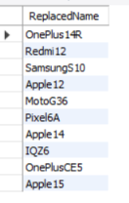
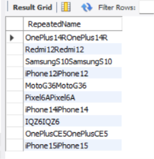
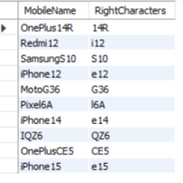
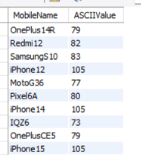
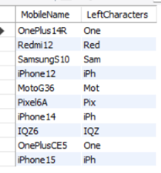
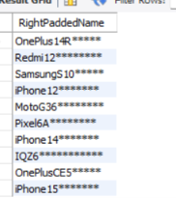
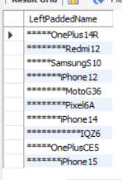

RESULT
Thus the MySQL string functions such as REPLACE, REPEAT, REVERSE, RIGHT, LEFT, RPAD, LPAD, ASCII, BIN and OCT were executed successfully.

